**Problem 1-Perform word count in Hive for above given dataset.**

**Input file**

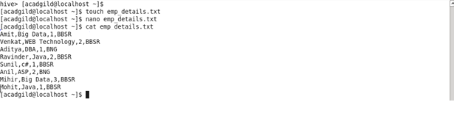

***Creating table and loading data***

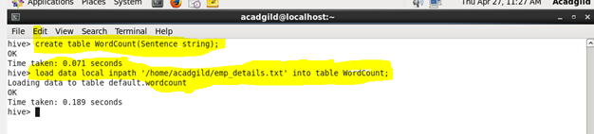

***Split command***

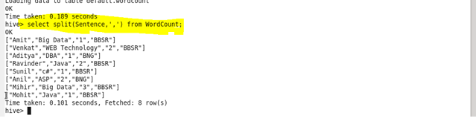

***Explode command***

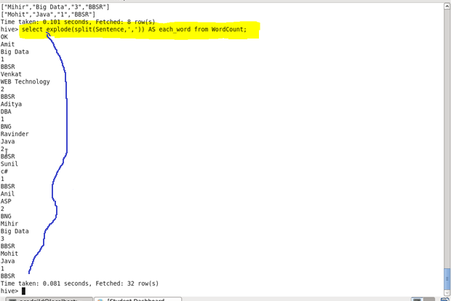

***Counting each word***

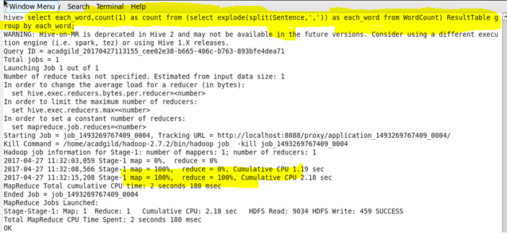

***Output***

